**Assignment 7**

**Performance Modeling for Convolutions on GPU and Results**

**All were run on a single GPU**

Q1) How many Flops needs to be done to compute a convolution of dimension k on a image of size

m*n?

1. Our Image size is m*n and our kernel size which would be used for convolution is k*k
2. In convolution, for a single pixel, we will do 2 times k*k operations ie with our kernel we will do multiplication first and then addition.
3. So for an image with a size of m*n, we will do a total of (m*n*k*k*2) flops.

Q2) ) How much memory needs to be moved to compute a convolution of dimension k on an image of

size n*m?

* We will bring the image of size m*n from memory also the kernel of size k*k.
* So we will need to fetch ((m*n)+ (k*k))*4 bytes from Global memory.
* Also, we will write back (m*n)*4 bytes to memory.
* As I am using **const float* __restrict__ kernel,** the kernel would be cached and we need to bring it only once.

Q3) Assuming the performance numbers you measured in assignment 5 , how long should

computing a convolution of dimension 3 on an image of 1024x768 take?

* Considering m*n= 1024 * 768 and k*k=3*3.
* From Assignment 5, we got our Flop rating as 3TB and Memory Bandwidth as 155GB/sec.
* Flop time for calculation= ((m*n*k*k*2)/ 3*10^12))= 4.71 usec.
* Memory time calculation= (2(m*n)+ (k*k))*4)/155*10^9 = 40.5 usec.

**Performance Model**

Peak flop= ((1024 *768)/ 4.71 * 10^-6) = 166 Gp/sec.

Memory flops= ((1024 *768)/ 40.5 * 10^-6) = 19Gp/sec.

**Expected Performance Graph**

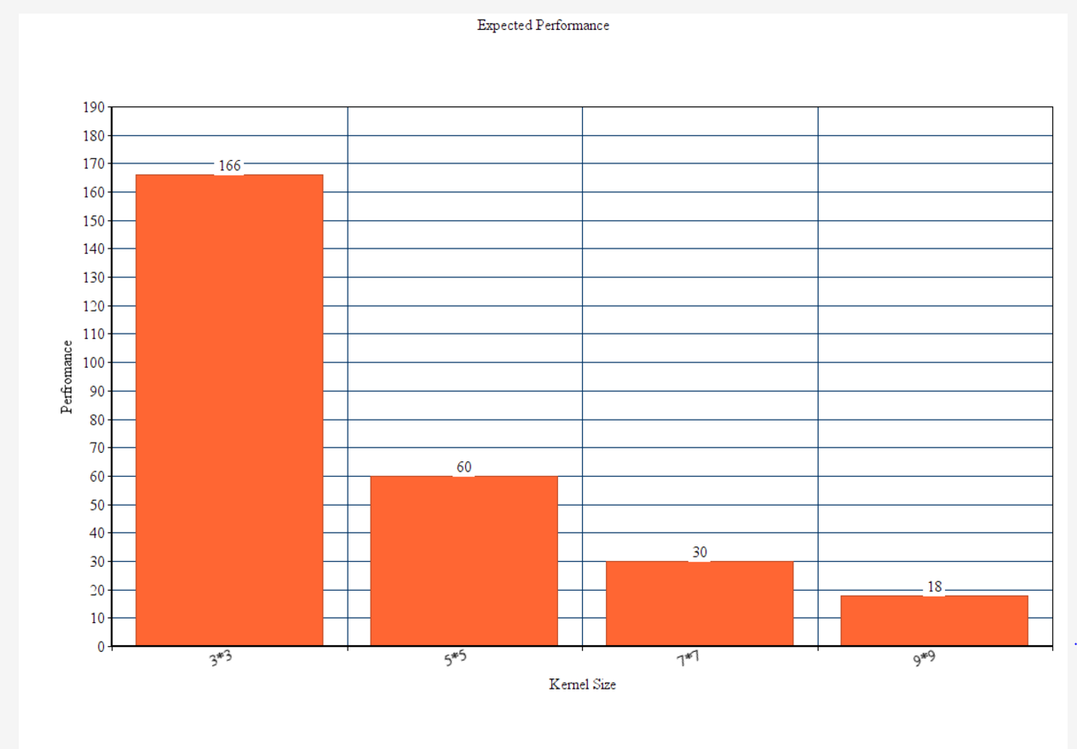

**Naïve _Convolution Performance**

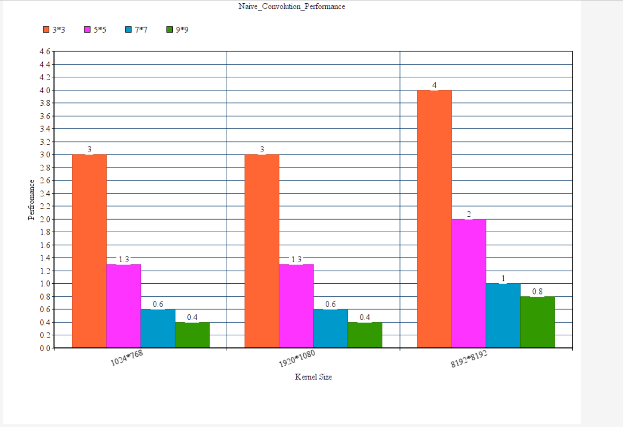

**Performance With using Shared Memory**

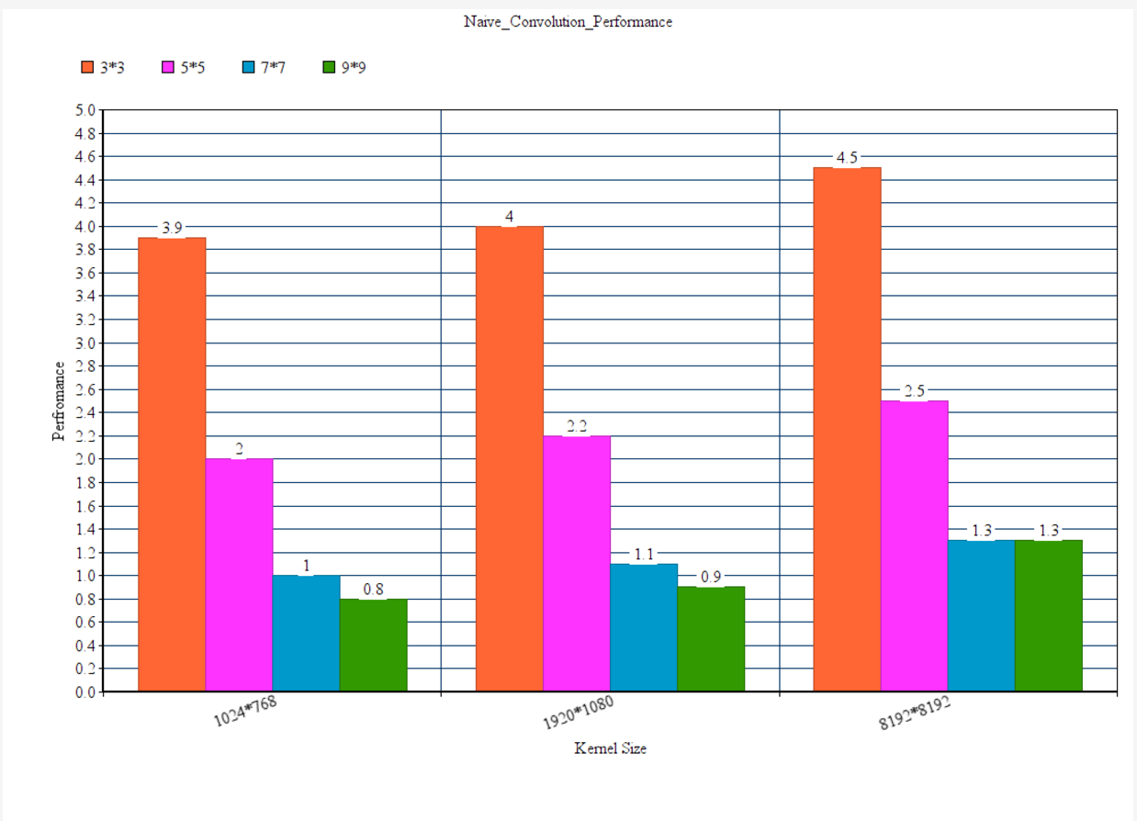

**We are able to get almost double the output using shared memory**